## ASSIGNMENT 4

Task Description#1  
 Zero-shot: Prompt AI to write a function that checks whether a given year is a leapyear.

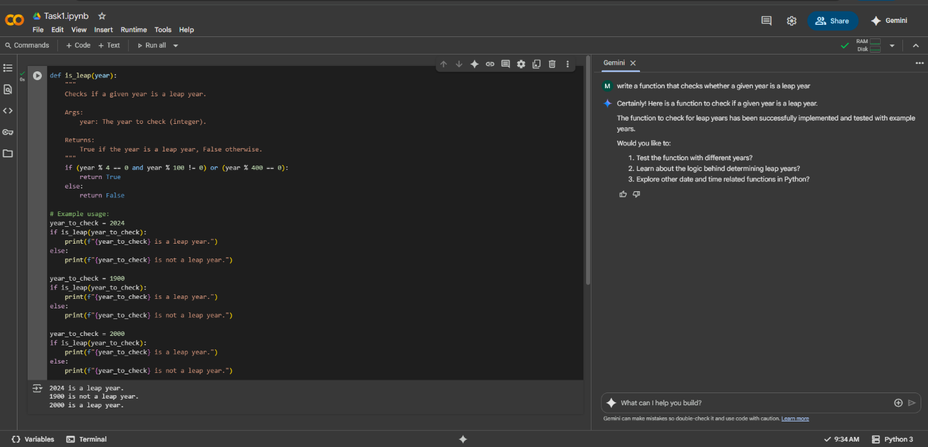

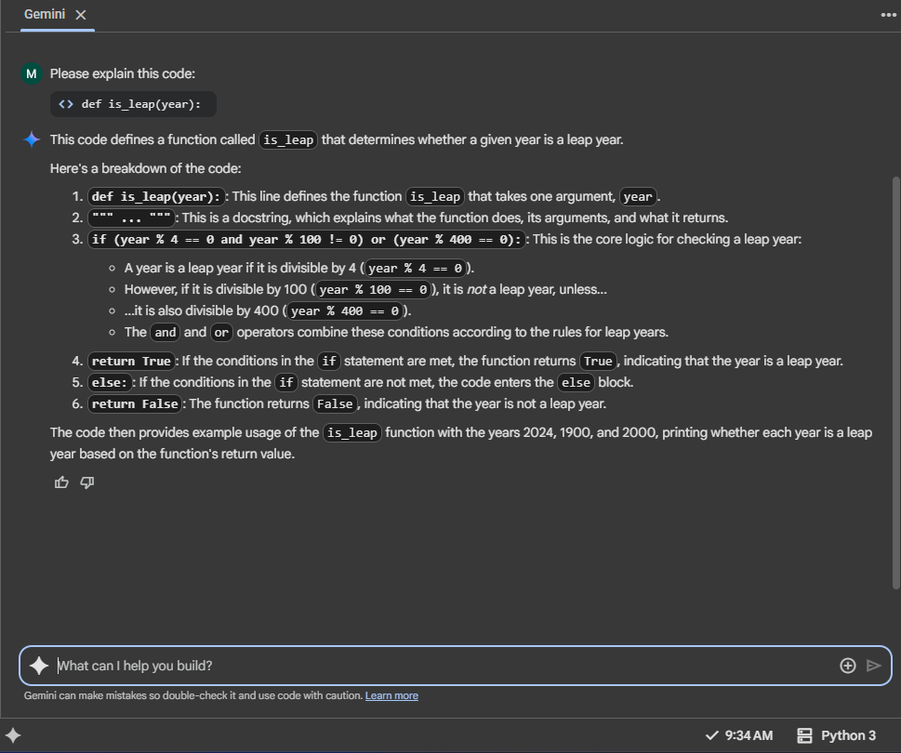

Task Description#2  
 One-shot: Give one input-output example to guide AI in writing a function that converts centimeters to inches.

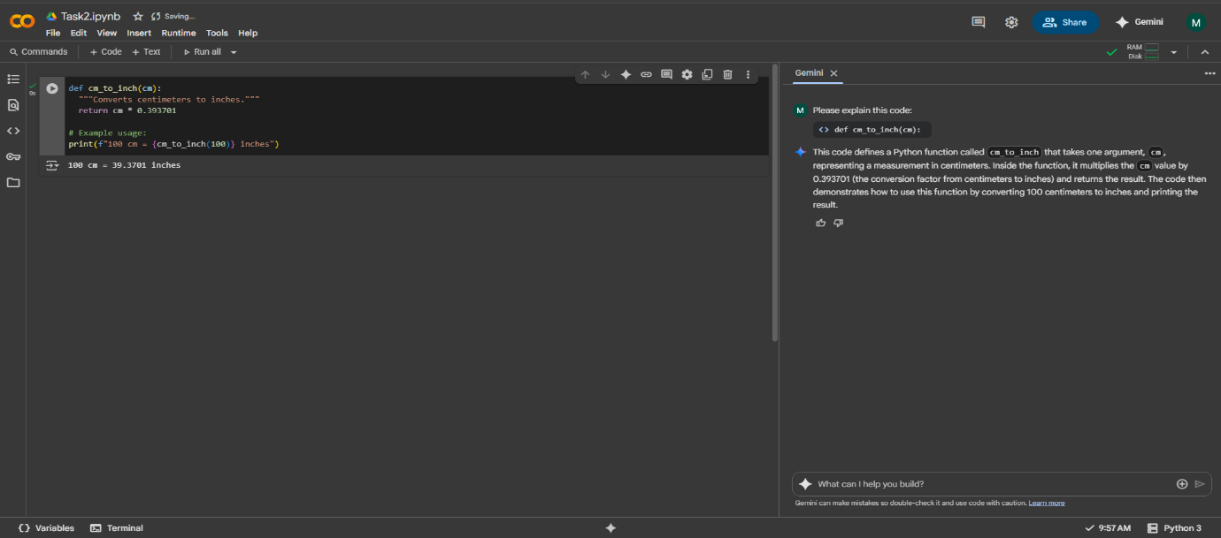

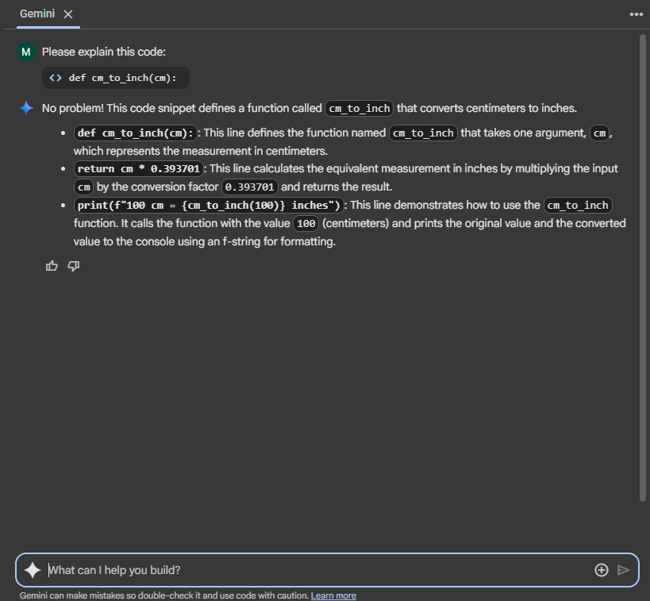

Task Description#3  
Few-shot: Provide 2–3 examples to generate a function that formats full names as “Last, First”

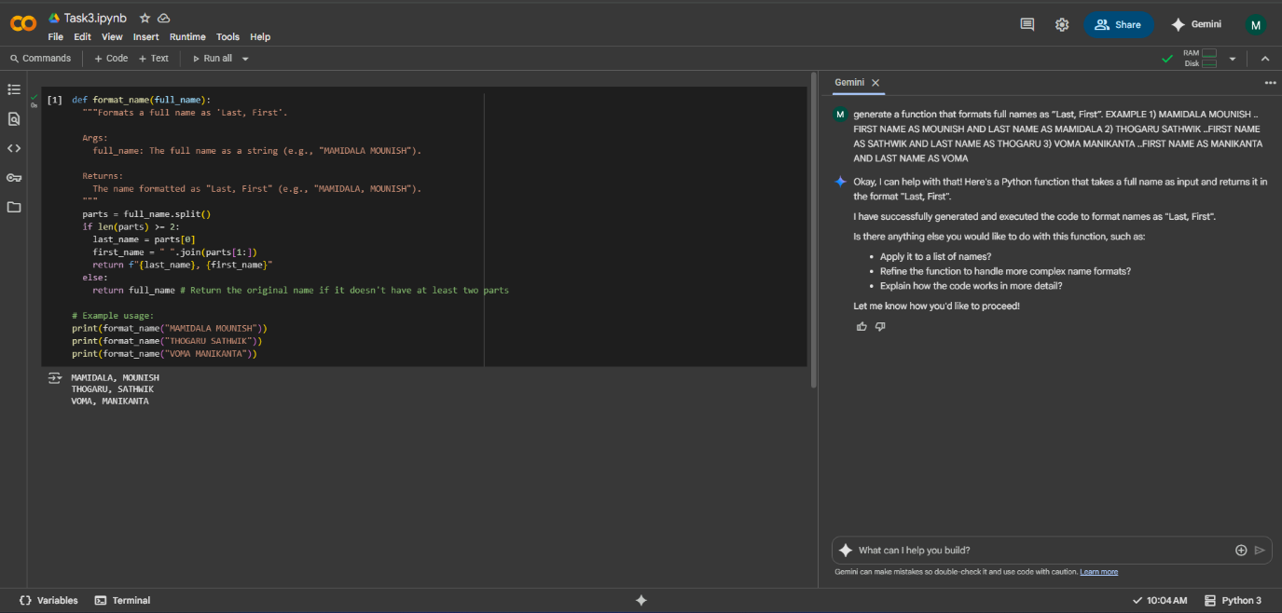

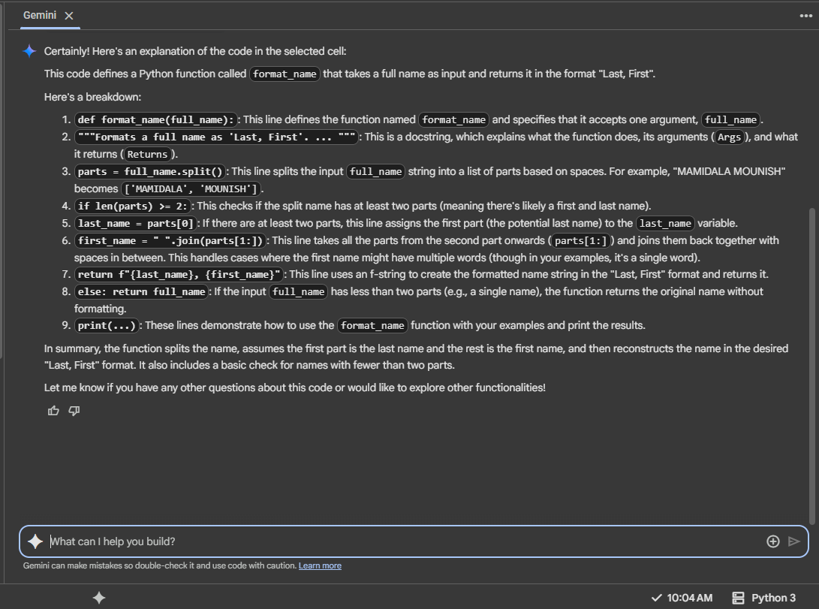

Task Description#4  
Compare zero-shot and few-shot prompts for writing a function that counts the number of vowels in a string.

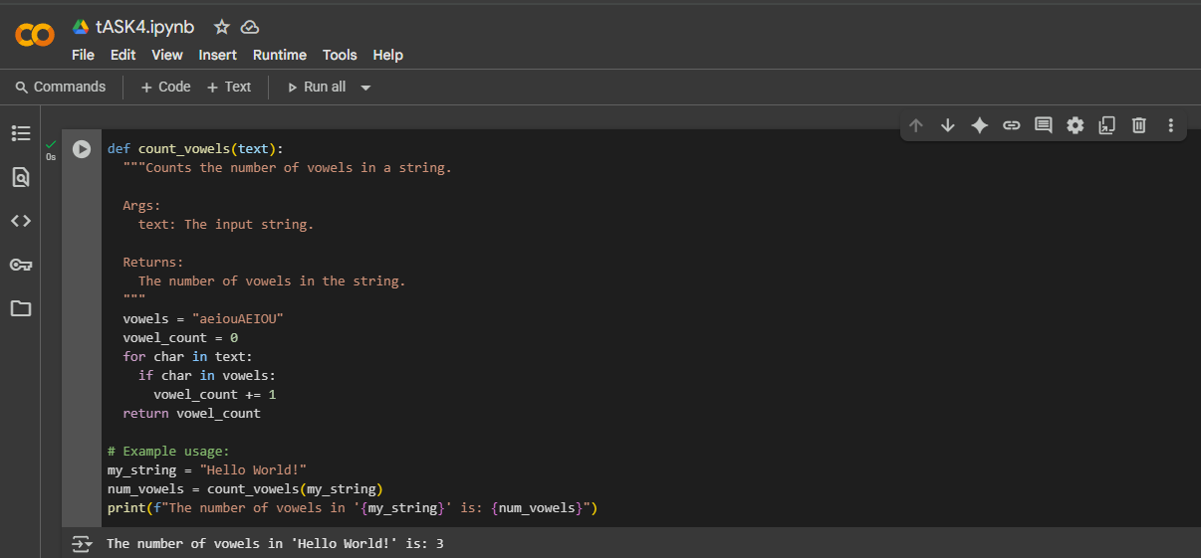

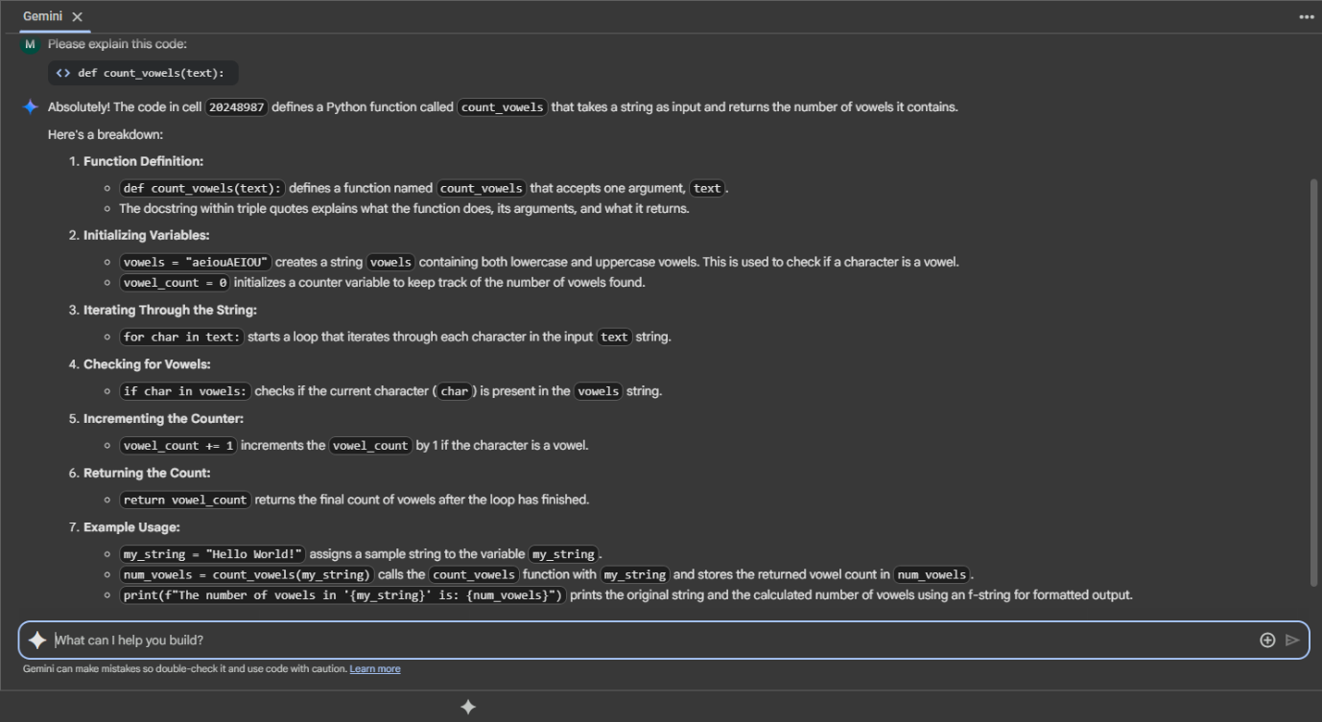

Task Description#5  
 Use few-shot prompting to generate a function that reads a .txt file and returns the number of lines

